The International Council for the Exploration of the Sea (ICES) offers courses led by high-profile scientists and instructors. Visit the Training web page: www.ices.dk/training

Stock assessment (Advanced)
Context and level
This is an advanced course in fisheries stock assessment modelling where we explore generic properties of stock assessment methods. The course includes uncertainty estimation of the relevant parameters estimated in stock assessments. It is aimed at scientists who have some foundation in the fundamentals of stock assessments.
In the course we examine various assumptions as well as strength and weaknesses of different methods. The course will take you through the different steps that are part of any stock assessment. First: exploratory data analysis and the potential information content in the available data; Second: we discuss setting up structured population dynamic models. As a third step, we link these population dynamics models to existing data by calculating model predictions for catch, survey, and other relevant types of data. We discuss and demonstrate fitting the models to data using likelihood functions. To this end, we work with different optimizing/sampling tools. Finally and importantly, we discuss how to estimate and present uncertainties in the stock assessment models that we build.
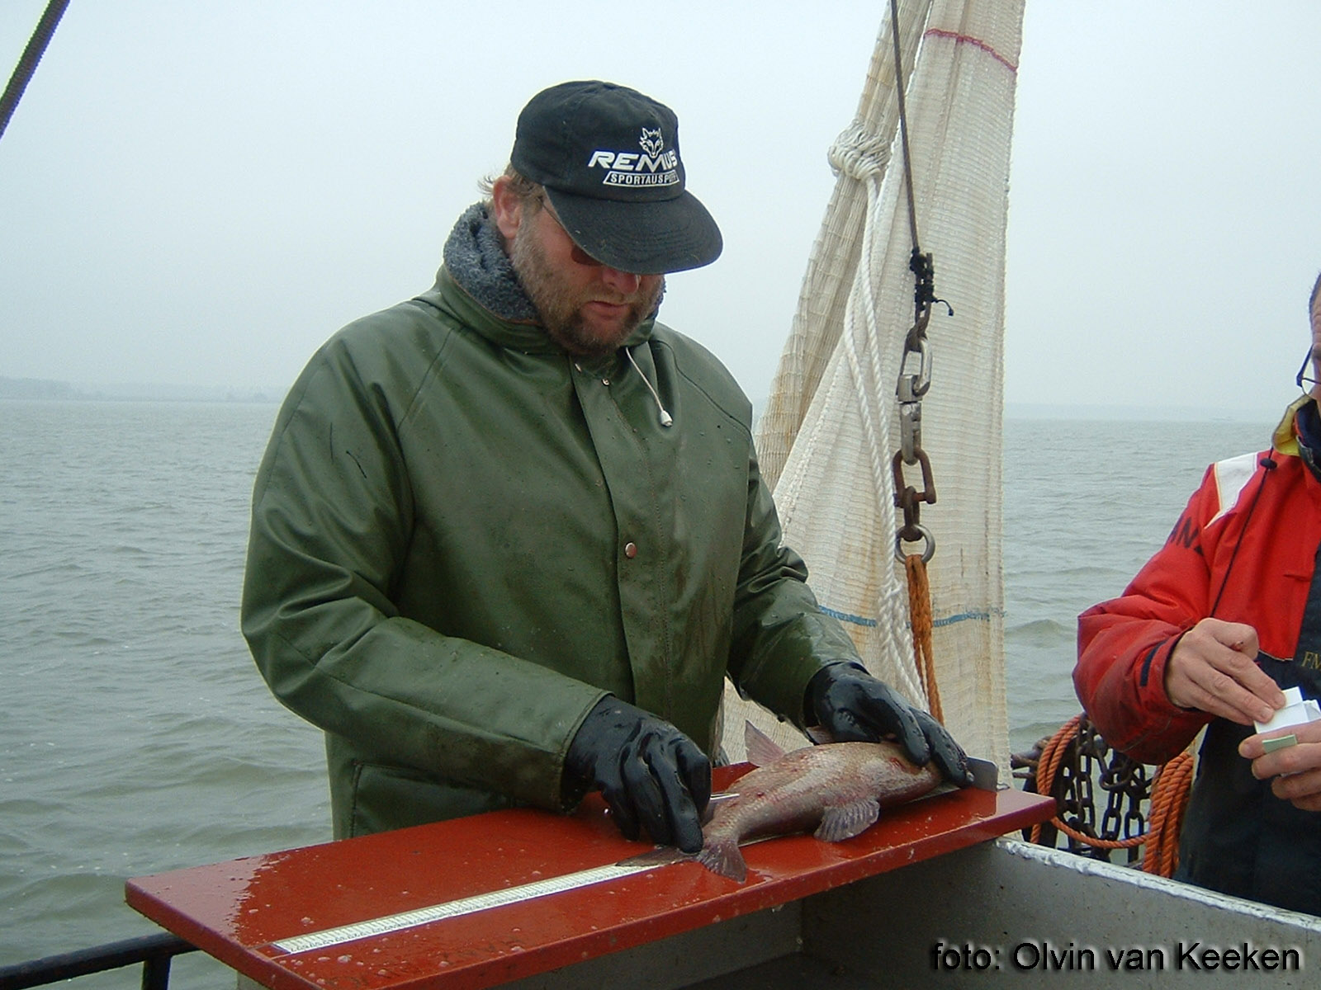
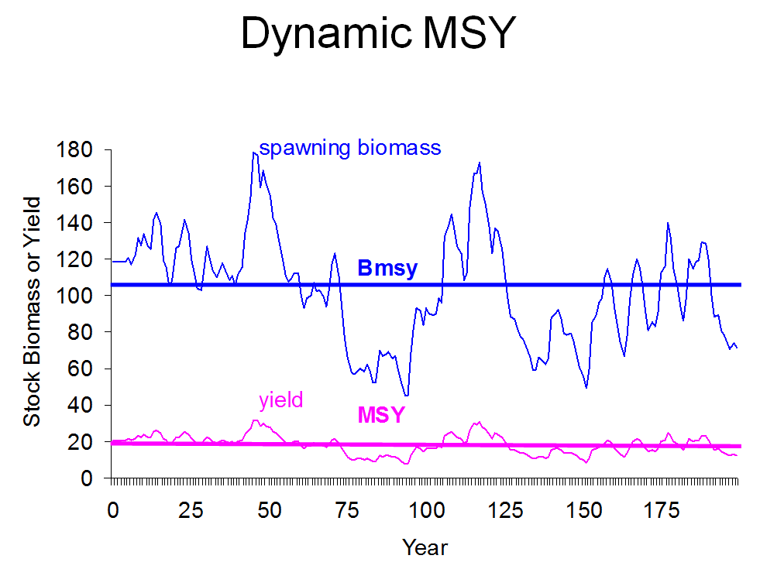
Besides the building of assessment models and estimating uncertainty using various tools we also discuss closely related analytical techniques to improve scientific advice for managers. We show some exploratory analyses to reveal existing patterns in the data at hand, and how fish stock dynamics can be modelled under different assumptions.

Objective
The general objective of the course is to train stock-assessment scientists and advisors in population dynamics and advanced stock assessment. The course intends to put theory into practice as much as possible by working on examples from different angles.

Course dates
18 – 22 November 2013

Programme
The five-day course is organized as a series of sessions with alternating focus on theoretical concepts and hands-on work on examples. These example sessions will be completed in different software environments such as R and AD model builder (see flr-project.org and admb-project.org).

Day |  | Topic
Monday | AM | Introduction assessments & populations
 | PM | Lab population dynamics
Tuesday | AM | Likelihood estimation and optimizers
 | PM | Lab stock assessment
Wednesday | AM | ADMB and uncertainty estimation
 | PM | Uncertainty estimation and Bayesian models
Thursday | AM | Assessment model formulation
 | PM | Use of tagging data
Friday | AM | Harvest control rule simulation
 | PM | Summary and working on participants’ data

Venue
International Council for the Exploration of the Sea
H. C. Andersens Boulevard 44-46
DK-1553 Copenhagen V
Denmark
Tel: +45 3338 6700, Fax: +45 3393 4215
info@ices.dk
You can find more information about:
ICES HQ here
Hotels close to ICES here
The hostel next to ICES here

Fee
The fee for the course is €750. This covers only tuition fee.

Organization
The course is organized by the ICES Secretariat as part of the ICES Training programme.
The course and course materials are provided by Jan Jaap Poos, Wageningen IMARES and Richard Hillary, CSIRO Marine and Atmospheric Research.
The course includes background information, applied examples, and hand-on exercises.
Participants are required to bring their own laptops (preferably with MS windows or a GNU/Linux distribution) to connect to ICES network.

Admission and registration
The course is designed for a maximum of 25 participants. The working language is English.
Please use the on-line registration:
www.ices.dk/training
The deadline for the submission of applications is
17 September 2013.

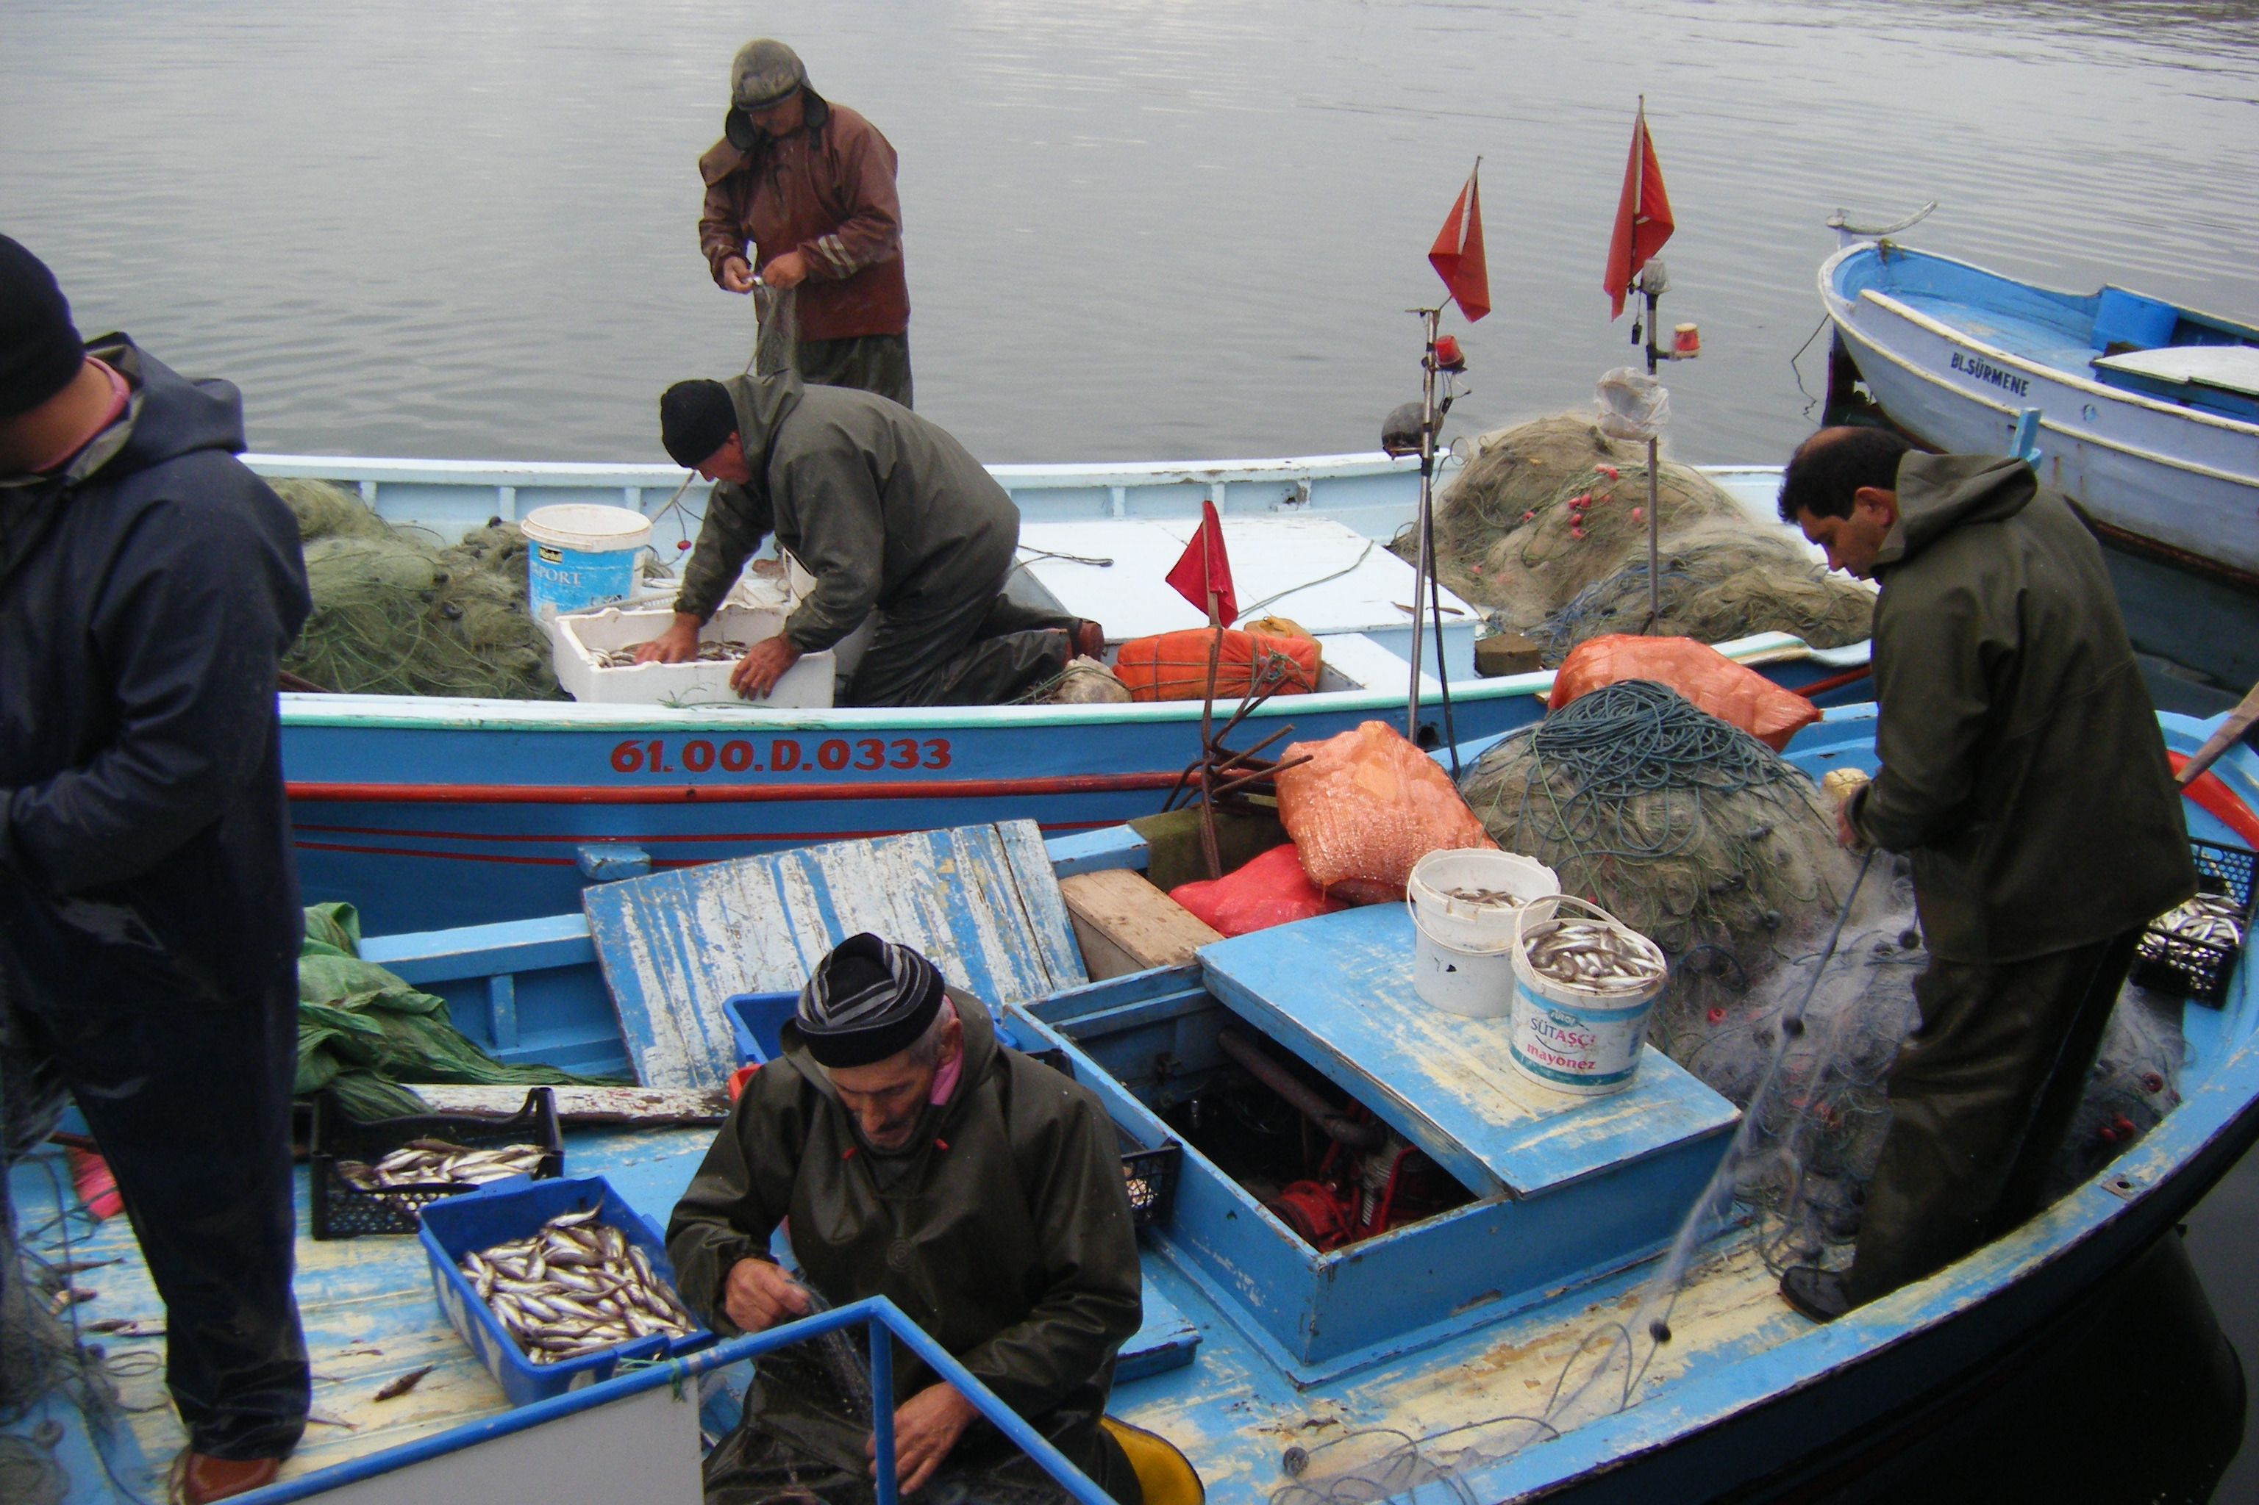

Instructors
Jan Jaap Poos,
Wageningen IMARES
PO Box 68
1970 AB IJmuiden, The Netherlands
janjaap.poos@wur.nl

Richard Hillary,
CSIRO Marine and Atmospheric Research
Castray Esplanade
Hobart 7001, Australia
Rich.Hillary@csiro.au

Contact ICES Secretariat for more information
Søren Anker Pedersen, Coordinator for Training
Tel: (45) 33 38 67 52
Email: mailto:training@ices.dk
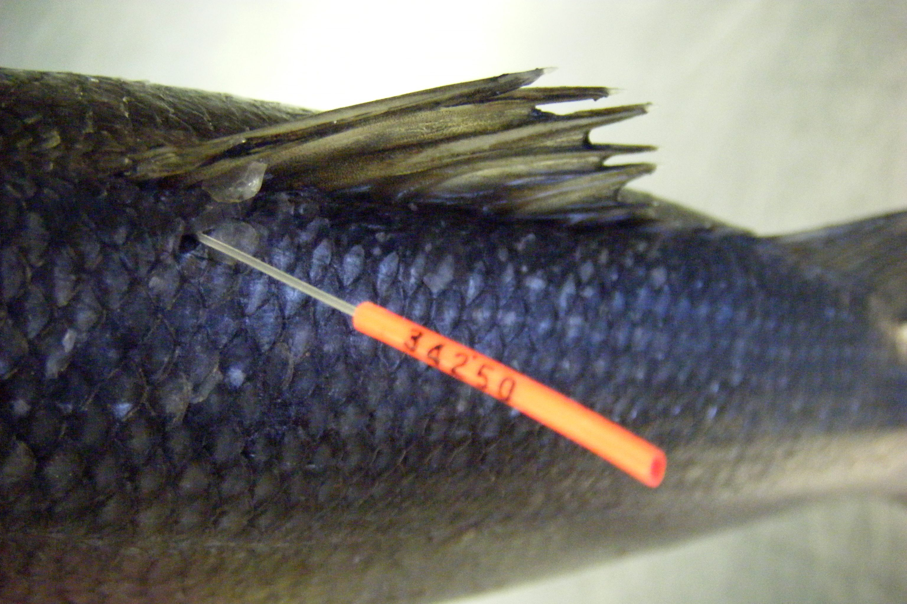

The course fee for participants from non-ICES member countries is 1250 €

